Geochemistry of river suspended sediments in tropical watersheds:
anthropogenic and granite-gneiss sources, SE Brazil

Carla Semiramis Silveira¹*; Vitor Schwenck Brandao¹; Alfredo Victor Bellido Bernedo¹; Jose Luiz Mantovano²
¹ Programa de Pós-Graduação em Geoquímica –Institute of Chemistry – Universidade
Federal Fluminense (UFF), Rio de Janeiro, Brazil
² Comissão Nacional de Energia Nuclear (CNEN), Rio de Janeiro, Brazil
* corresponding author. Outeiro de Sao Joao Batista s/n, Departamento de Geoquimica
(5o andar), Instituto de Quimica, - Campus Valonguinho. Universidade Federal
Fluminense

Keywords: mineralogy; total suspended sediment; pollution

Introduction
Rivers are good indicators of the geochemical processes that occur in a watershed. Especially the total suspended sediment (TSS) is the result of a variety of natural factors such as size, relief, geology and climate, alongside anthropogenic factors (land use and engineering constructions) (Milliman & Syvitski, 1992). Hydrological conditions regulate mineral sorting processes, which can affect the mineralogy and thus the geochemistry of the TSS, masking a source (Garcon et al., 2014) or providing differences with depth (Bouchez et al., 2011). The TSS has a higher importance to elemental fluxes from the continent to the oceans than the dissolved load. With exception of the very soluble constituents, elements are largely transported as suspended particulate matter (Gaillardet et al. ,2003; Viers et al., 2009). The TSS mineralogical and geochemical composition are also useful to establish sources zones and build a fingerprinting from both natural and anthropogenic processes that act in the watershed (Walling et. al., 2002; Hudson-Edwards, 2007). Even now, there are large uncertainties associated with the chemical composition of the TSS that justifies acquiring more data (Viers et al, 2009). Small rivers are the ones that are the most impacted by great magnitude disasters, such as landslides and floods. However those watersheds lack data (Milliman & Syvitski, 1992; Syvitski, 2003). This study aims to contribute with TSS geochemical data from a small watershed (2 x 103 km2) in the southeast of Brazil. Although a small watershed, Piabanha River is one of the most important affluents from Paraiba do Sul River, the main coastal river on the southeast of Brazil.

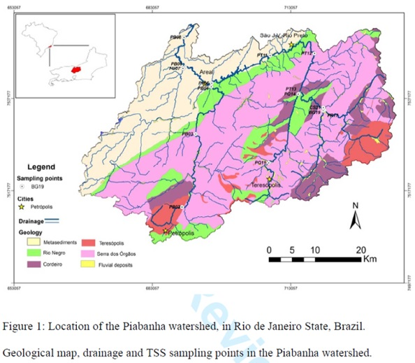

The total suspended sediment (TSS) is the result of geogenic and anthropogenic factors. Mineralogy and geochemistry results from a granite-gneiss watershed in southeast Brazil brought light to these sources. TSS was sampled in 15 points along the Piabanha watershed in summer (February – 2013) and winter (August – 2013).
ZnO, CuO, As2O3, CaO, Na2O, P2O5 and SO3 associated to sewage source.

Conclusions
• Quartz, kaolinite and gibbsite followed by feldspar and mica were the major TSS mineralogy from the Piabanha watershed.
• The TSS geogenic source contrasts with the pollution source from domestic waste water downstream from the two main cities of the watershed.
• Granite and gneiss rocks contributions in the TSS of the Piabanha watershed
show a common mineralogical and geochemical source. But the alluvial deposits from river banks might have been responsible for the differences between summer and winter samples.
• The major features from geogenic granite-gneiss and alluvial deposits were SiO2, Al2O3, MgO, Ga2O3, Nb2O5, Rb2O, K2O, SrO, ZrO2 and TiO2. They showed a good correlation with the Si:Al molar ratio and suggested that the source area is intensely weathered. Pollution features were shown by a significant TSS concentration of Fe2O3, MnO, ZnO, CuO, As2O3, CaO, Na2O, P2O5 and SO3 due mainly to sewage source.

