TITLE

A. B. CABRAL
INSTITUTION
email address

B. C. DELFIN
INSTITUTION
email address

C. D. ESTEVES
INSTITUTION
email address

Abstract

The abstract characterizes a synthesis of the research description and must present the main information and follow the guidelines: single paragraph, 100 to 300 words, justified text, regular, Calibri font, size 11, single spacing, without bibliographic references, tables, graphs, quotes, or highlights of any nature. It must include the synthesis of the work, the theoretical-methodological framework, and the main results. Also

Key-words: from 3 (three) to 5 (five) terms, separated by a comma and ending with a period.

1 INTRODUCTION

Introduction must present general context, objective and outline the theme.
Throughout the file, use Calibri 12 font (except for the title, Calibri 14, and for the abstract, Calibri 11).
The full research description summary must contain 2 to 3 numbered pages, using A4 format, margins top/left 3.0 cm and bottom/right 2.0 cm, paragraph 1.25 cm, with single line spacing, containing Introduction, Methodology, Results and Discussion, Final Considerations, Acknowledgments (optional) and References in accordance with ABNT.
The file must be attached in WORD (.DOCX) format, with a maximum size of 10MB.

2 METHODOLOGY

The methodology must present the methodological paths and use of tools, research techniques and instruments for data collection, inform, when relevant, about approval by ethics committees or equivalent, and about the right to use images.
Figures can be included centered on the page and numbered in Arabic numerals. The caption appears below, as seen in the followed figure.

.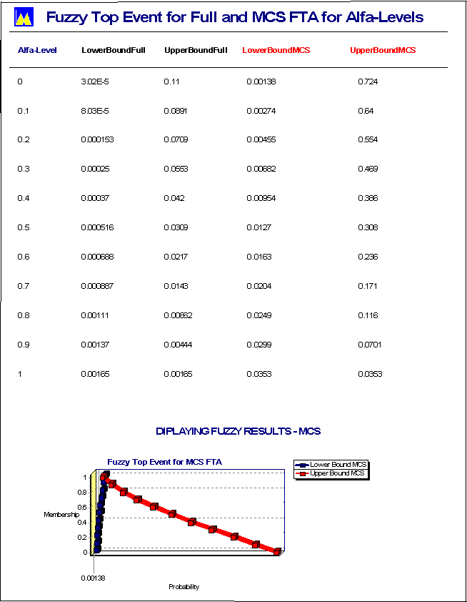
Figure 1: Ranking to fuzzy top event

Tables can be included centered on the page and numbered in Arabic numerals, but the caption appears before, as followed, in table 1.

Table 1: Frequency of Release - EndState of the Event Tree
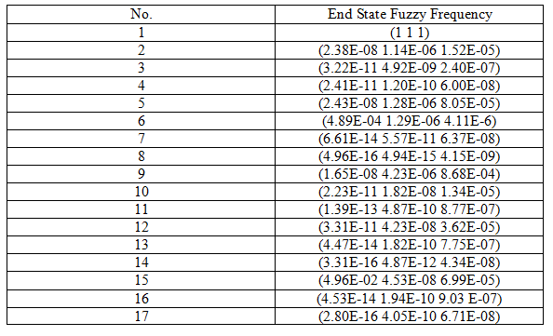

3 RESULTS AND DISCUSSION

This session must include a schematization of the data found, in the form of analytical categories and systematization of empirical findings.
Graphs, tables, and charts may be used, identified according to ABNT standards.

4 FINAL CONSIDERATIONS

In this session, some notes should be dedicated to the research main conclusions and prospecting of its empirical application to the scientific community. It also opens the opportunity for discussion about the need for new research in the field of activity, as well as dialogues with the analyzes mentioned throughout the summary.

5 ACKNOWLEDGMENTS (OPTIONAL)

REFERENCES

Present only the references used in the text, following the current ABNT standards. Examples below.

[1] ANEZIRIS, O.N.; HOUSIADAS, C.; STAKAKIS, M.; PAPAZOGLOU, I.A. Probabilistic safety analysis of a Greek Research Reactor, Annals of Nuclear Energy 31 (2004) 481–516.

[2] GUIMARÃES, A.C.; MOREIRA, M.L. PS Assessment Applied to Research Reactors. In: Amir Zacarias Mesquita. (Org.). Current Research in Nuclear Reactor Technology in Brazil and Worldwide. 1ed.Rijeka: InTech, 2013, v. 1, p. 125-149.

